**Solution – 1 -:**

Given mean= 70

variance = 200

hence mean for 10 adults = 10(70) = 700

variance for 10 adults = 10(200) = 2000

therefore, standard deviation sd = √2000​ = 44.72

If the weight > 800 kg causes the elevator to "unsafely" reach the ground, then we can find the upper tail of our normal distribution:

P (Weight of 10 adults > 800 kg).

Z – score = (X – mu)/SD = (800 – 700)/44.72 = 2.24

Hence P (Z <2.24), using z table we get 0.9875 or 98.75%

Hence it is safe to reach the ground when there are 10 adults in the lift.

**Solution – 2 -:**

The total sample size is N = 500. Therefore, the total degrees of freedom are:

dftotal = 500 - 1 = 499

The between-groups degrees of freedom are dfbetween = 5 – 1 = 4, and the within-groups degrees of freedom are:

dfwithin ​= dftotal ​– dfbetween​ = 499 − 4 = 495

i,j∑​Xij ​= 499712

i,j∑​Xij2 ​= 499691630

SStotal ​= i,j∑​Xij2 ​– 1/N (i,j∑​Xij​)2 = 267464.112

SSwithin ​= 266084.42

​ SSbetween​ = 1379.692​

MSbetween​ = SSbetween ​/ dfbetween​​ = 1379.692​ / 4 = 344.923

MSwithin = SSwithin​ / dfwithin​​ = 266084.42 / 495 ​= 537.544

F = MSbetween / ​MSwithin ​​= 344.923 / 537.544​ = 0.642

The following null and alternative hypotheses need to be tested:

H0 ​: μ1 ​= μ2​ = μ3 ​= μ4​ = μ5​

H1 ​: Not all means are equal.

The above hypotheses will be tested using an F-ratio for a One-Way ANOVA.

Based on the information provided, the significance level is α = 0.05, and the degrees of freedom are df1 ​= 4 and df2 ​= 4, therefore, the rejection region for this F-test is R = {F : F > Fc ​= 2.39}.

Test Statistics

F = MSbetween / MSwithin = 344.923 / 537.544​ = 0.642

Since it is observed that F = 0.642 < 2.39 = Fc​, it is then concluded that the null hypothesis is not rejected. Therefore, there is not enough evidence to claim that not all 5 population means are equal, at the α = 0.05 significance level.

Using the P-value approach: The p-value is p = 0.633, and since p = 0.633 ≥ 0.05,

it is concluded that the null hypothesis is not rejected. Therefore, there is not enough evidence to claim that not all 5 population means are equal, at the α = 0.05 significance level.

**Solution – 3 -:**

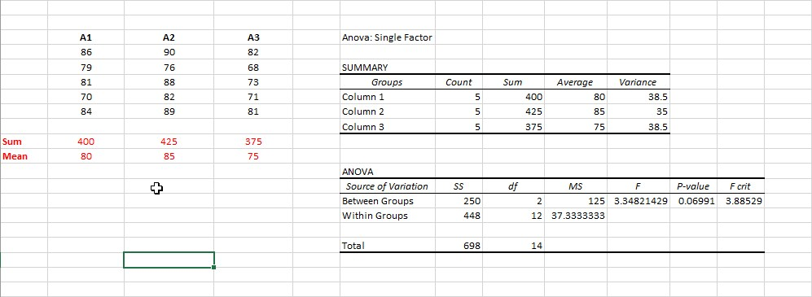

We have the sample of the scores of 15 trainees (A1, A2, A3). Each group consists of 5 trainees. We calculate the mean of each group. We should find out whether these means are different significantly (whether they were chosen from the different populations), α = 0.05.

H0 ​: μ1 ​= μ2 ​= μ3

​H1 ​: at least one of the means is different.

Using Single-Factor ANOVA in Excel we get p-value ≈ 0.069 > α.

So, we accept H0.

Three different types of the instructional approaches have the same effect on the trainees.